**Ansh Ranjan  
Databricks Case Study  
EXERCISE 4 – Data Storage and Retrieval**

**TASK 1: save the transformed data into Azure blob**

1. Mounting gold layer storage container  
   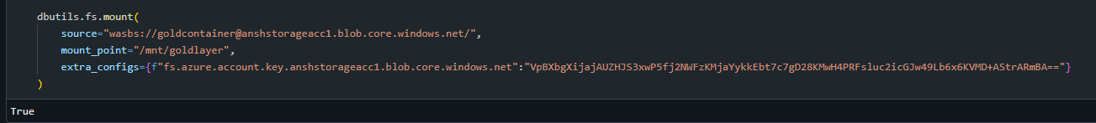
2. Writing the dataframe in form of Delta Tables in Blob container  
   
3. Checking data in gold container  
   A screenshot of a computer

   AI-generated content may be incorrect.

**TASK 2: Read the saved data back into df**

1. Reading the delta table back as a new df  
   A screenshot of a computer program

   AI-generated content may be incorrect.

**TASK 3: Explore Databricks Storage Options**

**Azure Databricks Storage Options**

1. **DBFS (Databricks File System)**
   * Managed storage layer built into Databricks.
   * Mounts your cloud storage as /dbfs/.
   * Easy for quick data loading and temp storage.

1. **Mounting Azure Storage (Blob or ADLS)**
   * Mount external storage (Blob or ADLS Gen2) to /mnt/your-mount-name.
   * Allows persistent storage with access to raw, bronze, silver, gold layers.
   * Uses dbutils.fs.mount() with access keys or service principals.

1. **Direct Access with ABFS or WASBS URLs**
   * No mount required.
   * Example: "abfss://container@storage.dfs.core.windows.net/"
   * Best for secure, scalable access with Unity Catalog.
2. **External Tables in Data Lake (Delta)**
   * Store Delta tables in ADLS or Blob and register them in Hive or Unity Catalog.
   * Enables scalable data lake architecture (bronze/silver/gold).